Using AutoHotKey v2
for updating the
FrSky Suite screenshots

Table of Contents
Overview 4
Preparation 4
Execution 8

Overview
This document describes how to use AutoHotKey v2 to update the ethos-manual FrSky Suite screenshots.

To update the screenshots we work inside a local folder of your choice. Once updated, the screenshots must be copied to your ethos-manual/<language>/assets folder and updated the normal way with a GitHub Desktop Pull, Commit and Push sequence.

Preparation

Configure your PC screen
1. Change your screen size to 1920 x 1080 which is the Windows HD size. Right-click in an open area on your desktop, and select ‘Display Settings.

Suite assumes 1920 x 1080 as the normal Windows screen size. If you screen size is different, Suite uses the Windows Scale factor to adjust to the bigger screen size. For consistency we will ask everyone to use this default size so that the x/y values for AutoHotkey simulated mouse clicks will target the correct location on the screen.

FrSky Suite Demo version

Installation
1. Download the FrSky Suite Demo version "FrSky-Suite-Windows-2.0.2.exe" that @Nicholas Luo uploaded to the #manual group on Discord on 10 October 2026.

2. Install the FrSky Suite Demo version. Note that as from this version the demo version of FrSky Suite has its own appID, which means it will exist separately to the normal FrSky Suite for day-to-day maintenance of your radio.

Configure the mock radio
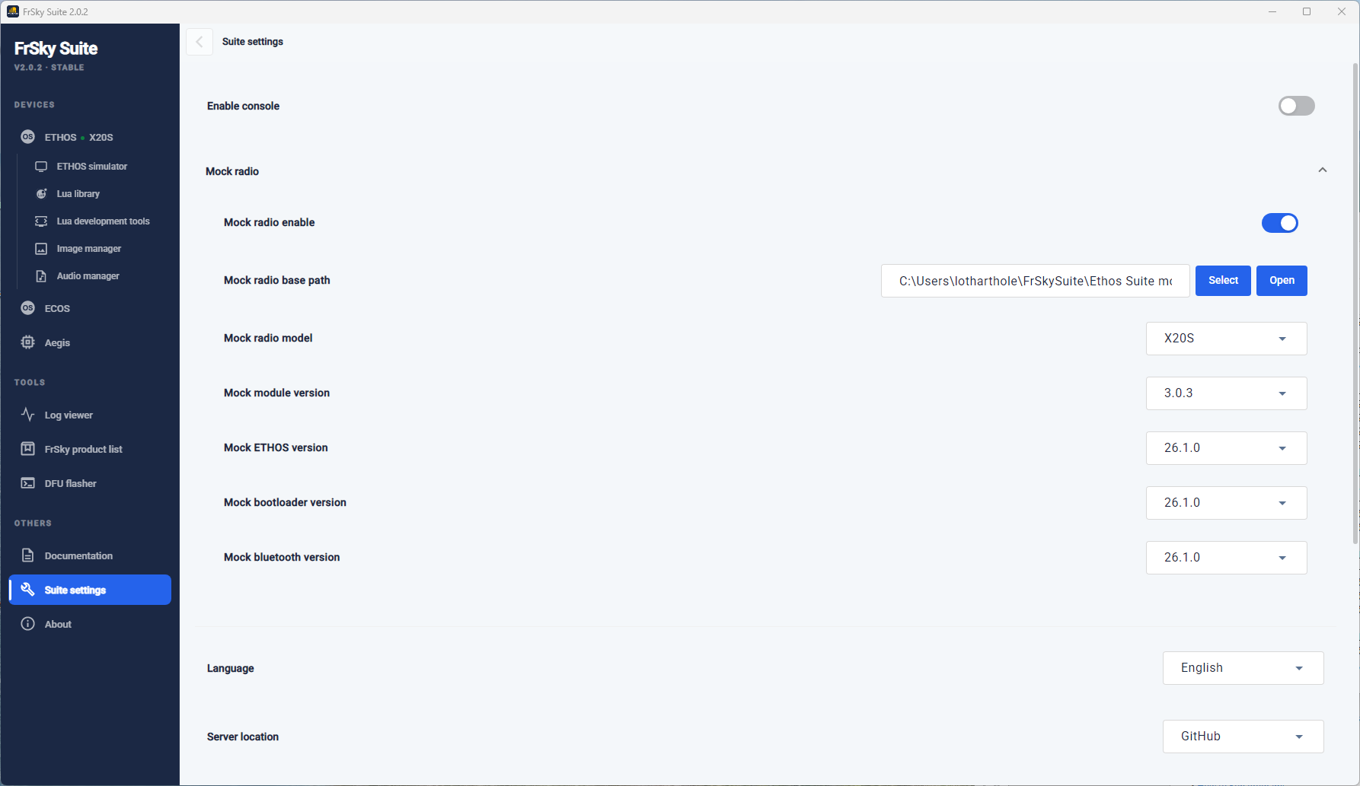

1. Go to the folder in your user area called FrSkySuite.

2. Create another folder inside FrSkySuite\Ethos Suite mock radio.

3. Go to Suite Settings.

4. Set the ‘Mock radio base path’ to the ‘ FrSkySuite\Ethos Suite mock radio’ folder you created in step 2 above.

5. Click on ‘Open’ and check that you can see the folder.

6. Once the mock radio path has been configured, enable the mock radio.

8. Switch to Devices / Ethos and check that it shows a radio connected. If not, you may have to disable and re-enable the mock radio. Only proceed once Devices / Ethos Suite shows a radio connected.

9. Go back to Suite Settings and set the other mock radio settings (i.e. version numbers) as shown above.

10. Now that the mock radio has created the standard folders it needs, copy the following folders with their contents from ethos-manual\forge into the ‘FrSkySuite\Ethos Suite mock radio\SD’ folder :
\models
\documents
\bitmaps
\scripts

Install audio files
Go to Manage Ethos, and install audio files using the normal method.

Configure the Suite ‘Backup location’
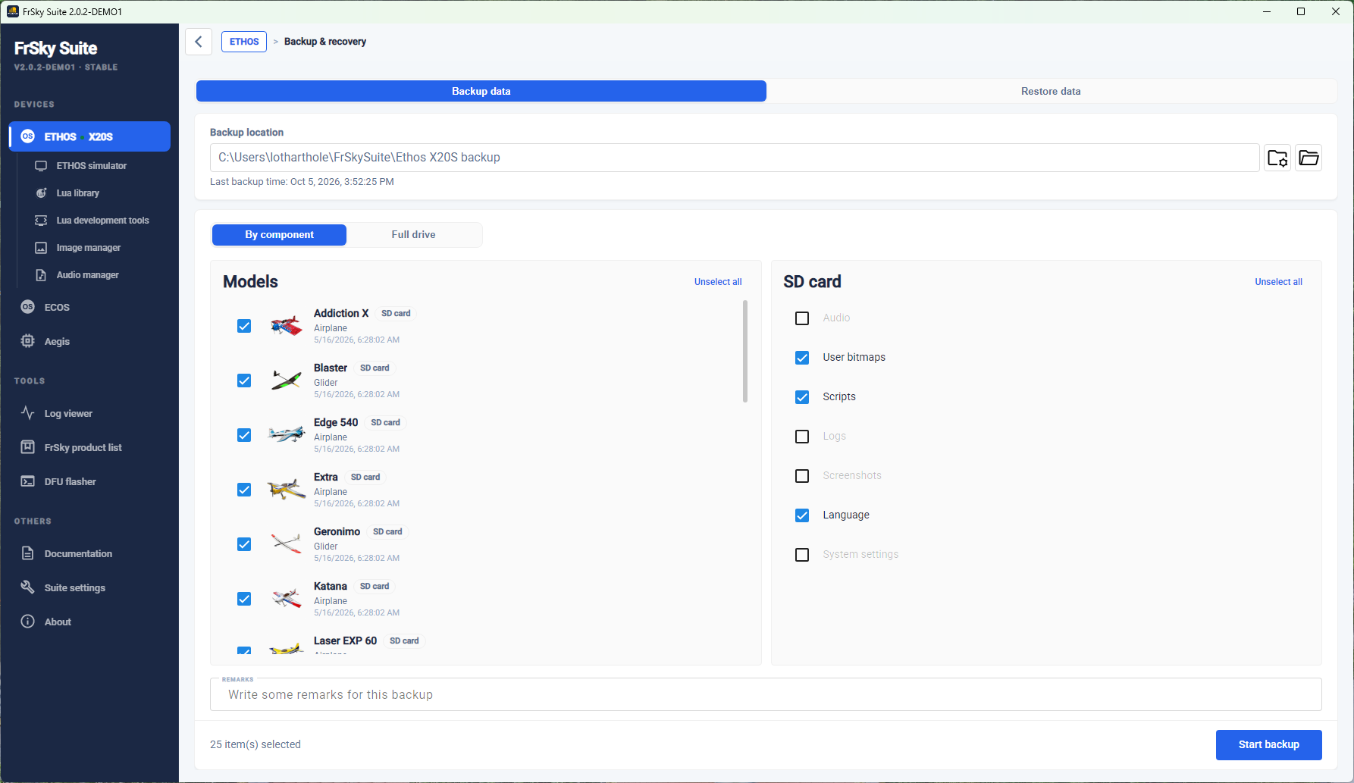

1. With the mock radio enabled, create a folder C:\Users\……...\FrSkySuite\Ethos X20S backup.

2. Go to Devices / Ethos / Backup & Recovery.

3. Configure the ‘Backup location’ to point to C:\Users\……...\FrSkySuite\Ethos X20S backup. Having a specific backup location for use with the mock radio to create screenshots for the manual means that this folder is separate and will not interfere with your normal use of Suite for your actual radio and models.

Configure the support files folder
1. Create a folder in your user area called FrSkySuite.

2. Create another folder inside FrSkySuite\files.

3. From your audio files copy ‘vfr-low’ to the \files folder.

4. From ethos-manual\forge\bitmaps\models copy Addiction_X.png to the \files folder.

5. Open FrSky Suite, click on the ‘Image manager’ tab, click on ‘Add images or drop files’ and browse to FrSkySuite\files\Addiction_X.png and load the image. Then delete it again. This establishes the path to the ‘files’ folder.

Configure the log files option
1. Go to the ‘FrSkySuite’ folder you created above..

2. From ethos-manual\english\autohotkey copy the ‘logs’ folder to the FrSkySuite folder.

3. Open FrSky Suite, click on the ‘Log viewer tab, click on ‘Click to select a file, or drag a file to this area’ and browse to FrSkySuite\logs\Ng-2m-2025-03-07-12-28-54.csv and load the log file. This establishes the link to the log file.

AutoHotKey v2
1. Download AutoHotKey v2. Go to https://www.autohotkey.com/v2/ and click on the ‘Latest installer’ link.

2. Install AutoHotKey v2.

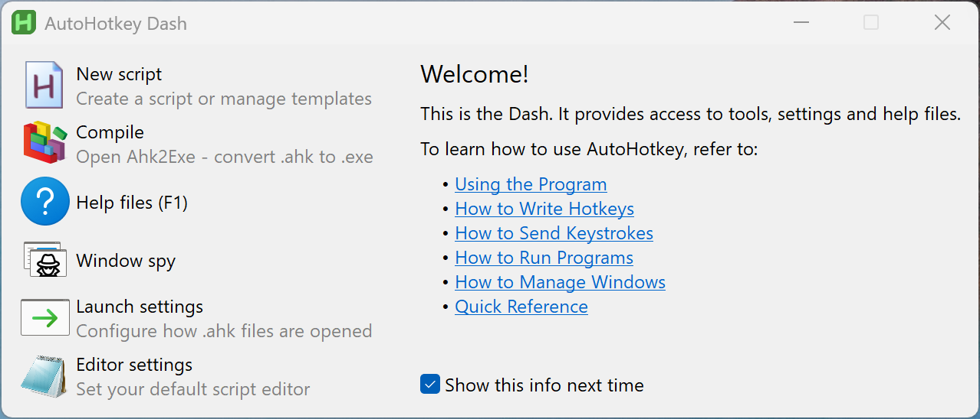

The AutoHotKey dash looks like this.

Click on some of the links to learn more about it.

We will use is to control FrSky Suite and take screenshots.

3. Click on ‘New script’.

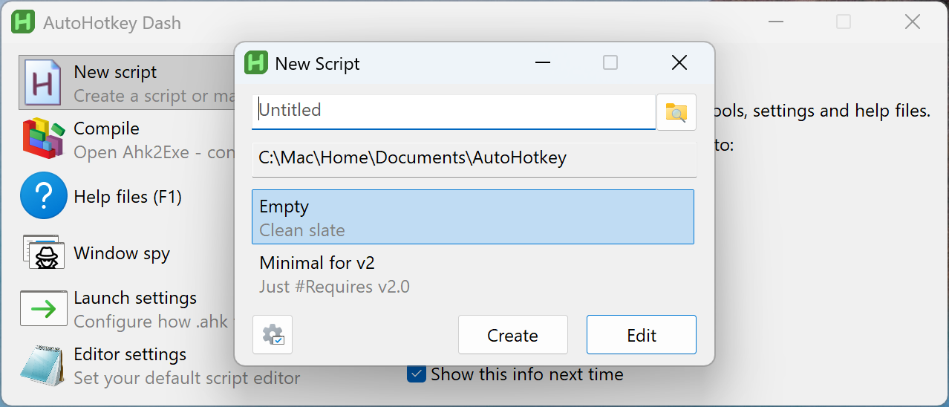

4. Click on Create. AutoHotKey will create an empty script in a new folder. Make a note of the folder location. You will use this location to store our Suite scripts, for example C:\...........\Documents\AutoHotkey.

5. Copy the ImagePut.ahk library file from ‘GitHub\ethos-manual\english\autohotkey\ ImagePut.ahk to your new \AutoHotkey folder.

6. Create a screenshots folder below the ‘AutoHotkey’ folder. This is where AutoHotkey will save the screenshots it creates.

FrSky Suite scripts for AHK2.
1. Download the config.ini configuration file from ethos-manual/english/autohotkey.

2. Open the config.ini with a code editor like VS Code.

[Paths]
; No quotes are needed around the path, even with spaces
SuitePath=C:\Program Files\FrSky Suite_demo\FrSky Suite.exe
ScreenshotsPath=C:\Users\lotharthole\autohotkey\screenshots

3. Edit SuitePath to point to your demo FrSky Suite app.

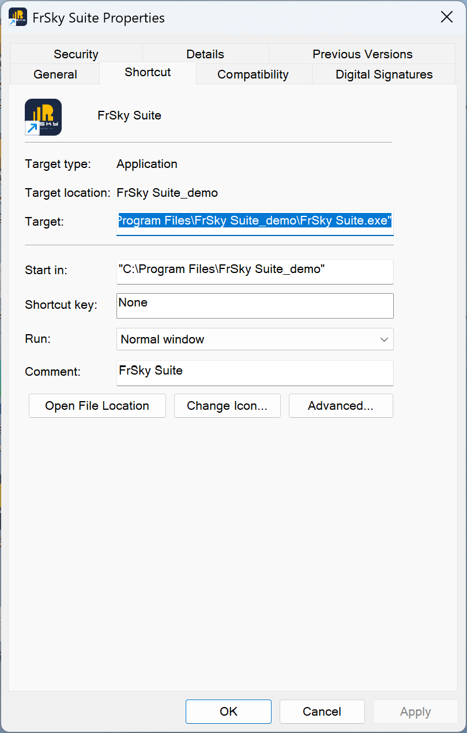

(To find the path to your demo FrSky Suite app, right-click on the icon on your desktop, select ‘Properties’ and copy the ‘Target’.)

4. Edit ‘ScreenshotsPath’ to point to the screenshots folder you created above.

5. Finally copy the most recent script from ethos-manual/english/autohotkey, eg. FrSuiteMacro_rev4.ahk to your AutoHotkey folder.

Execution

Configure your PC screen
1. Change your screen size to 1920 x 1080 which is the Windows HD size. Right-click in an open area on your desktop, and select ‘Display Settings.

Suite assumes 1920 x 1080 as the normal Windows screen size. If you screen size is different, Suite uses the Windows Scale factor to adjust to the bigger screen size. For consistency we will ask everyone to use this default size so that the x/y values for AutoHotkey simulated mouse clicks will target the correct location on the screen.

Configure the FrSky Suite mock radio versions
1. Open your demo version of FrSky Suite.

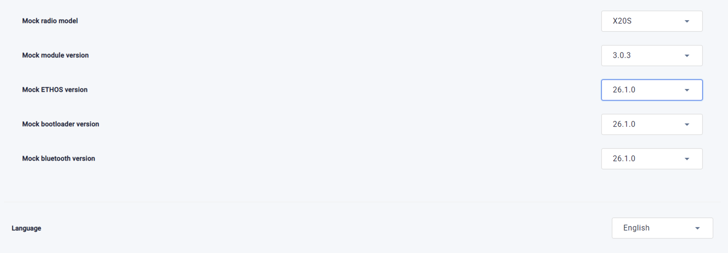

2. Configure the mock radio versions as shown above, but select your own Langauge.

3. Disable the mock radio. The script will turn it on when needed.

Run the AutoHotkey script
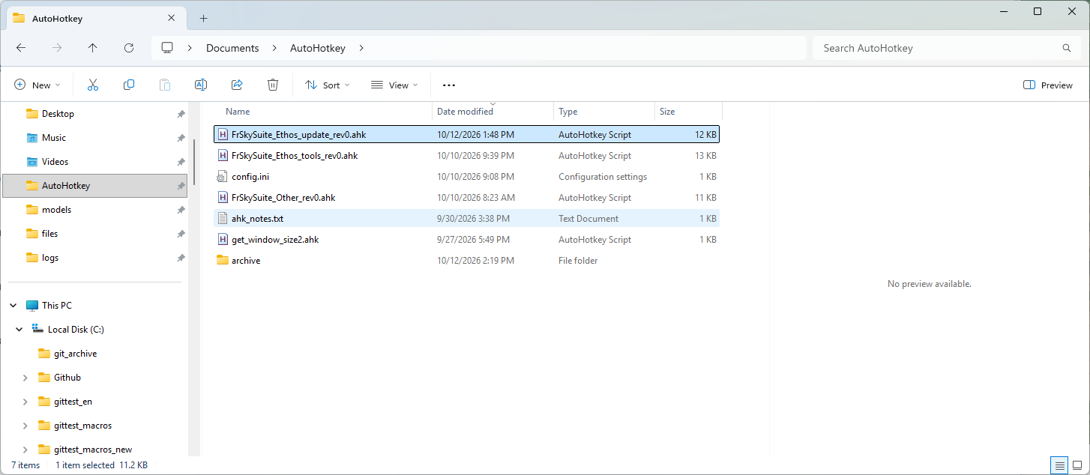

1. Open your AutoHotKey folder created above.

2. Double click on the most recent ‘FrSkySuite_Ethos_update_revxx.ahk’ script.

3. Optional deletion of previous screenshots.

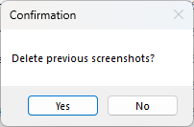

A dialog will ask whether you want to delete the previous screenshots. Click Yes if you want to delete them. In future you may want to run more than one script after each other, in which case you will not want to delete the screenshots folder contents.

4. The script will check whether the mock radio is in the correct state.
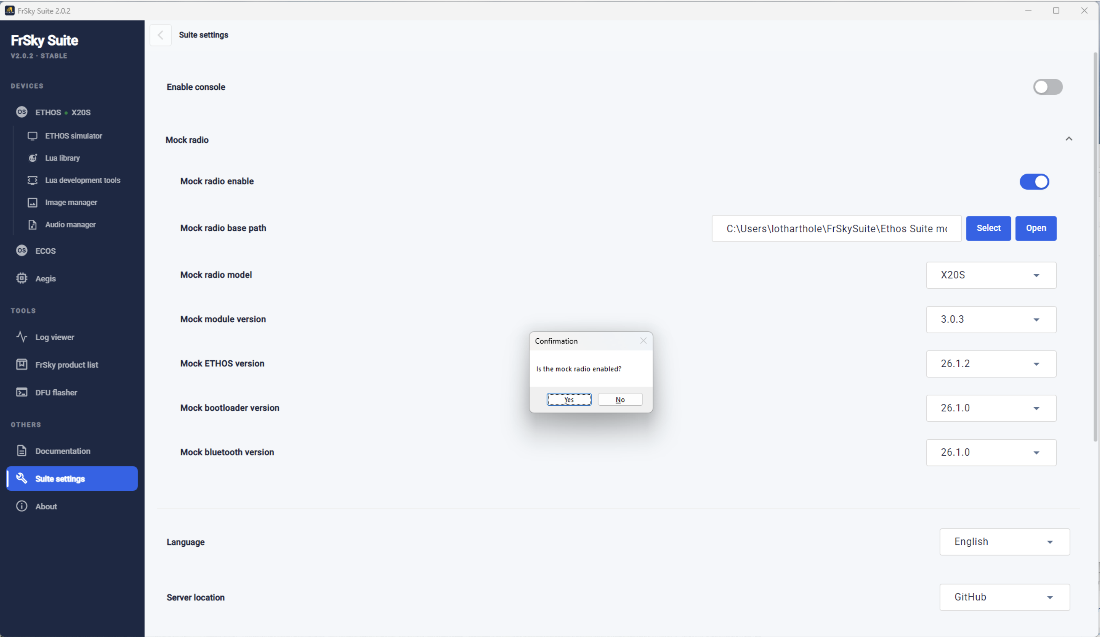

A dialog will pop up asking whether the mock radio is enabled. Check that the mock radio slider is enabled in the right hand position.

If it is not, it will ask you to close Suite and start the script again.

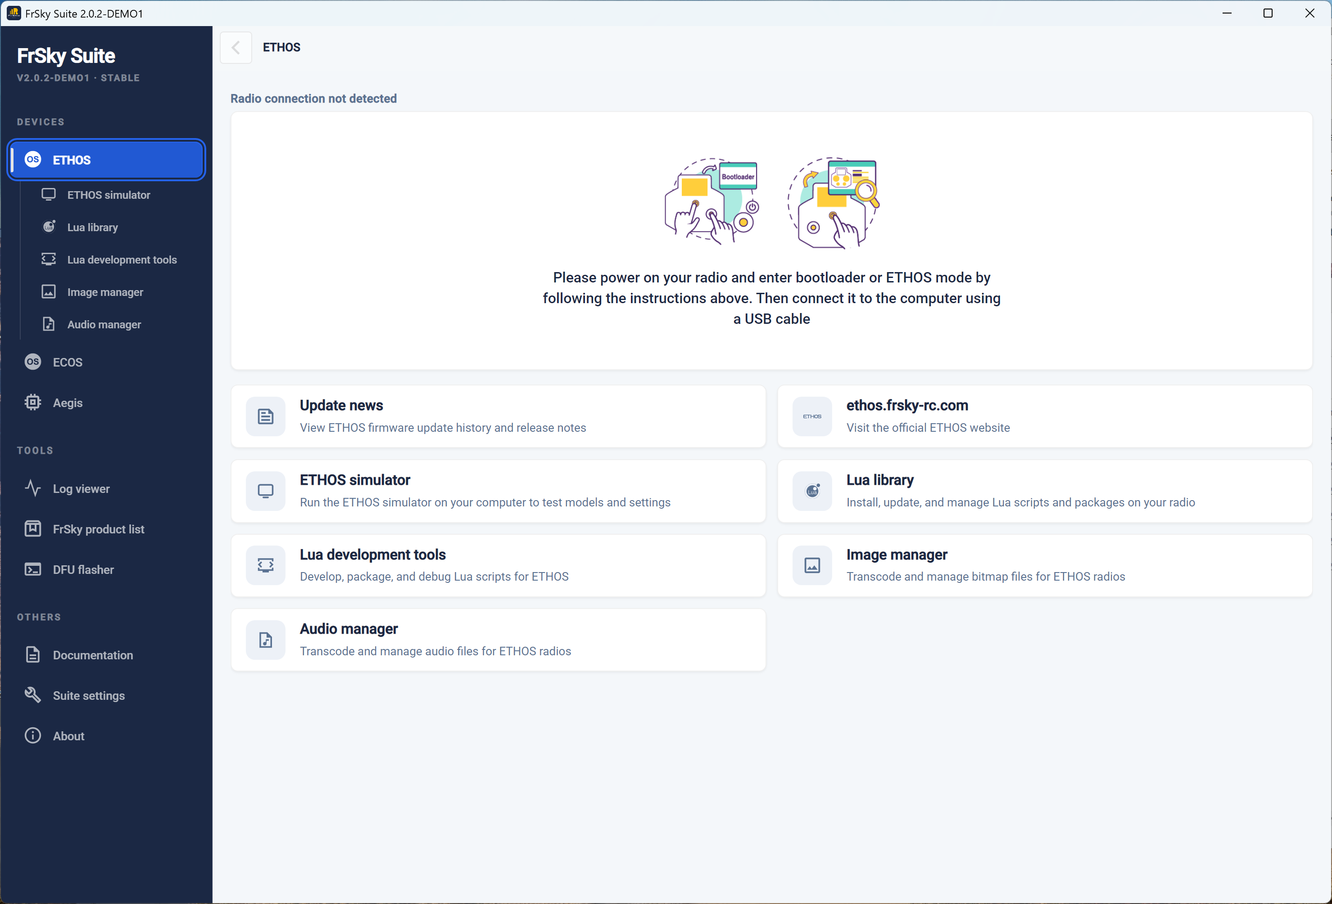

5. FrSky Suite should open as shown above if you are running the ‘FrSkySuite_Ethos_update_revxx.ahk’ script. It should then start stepping through the ‘Manage Ethos’ section.

If you are running one of the other scripts, the process will obviously be different.

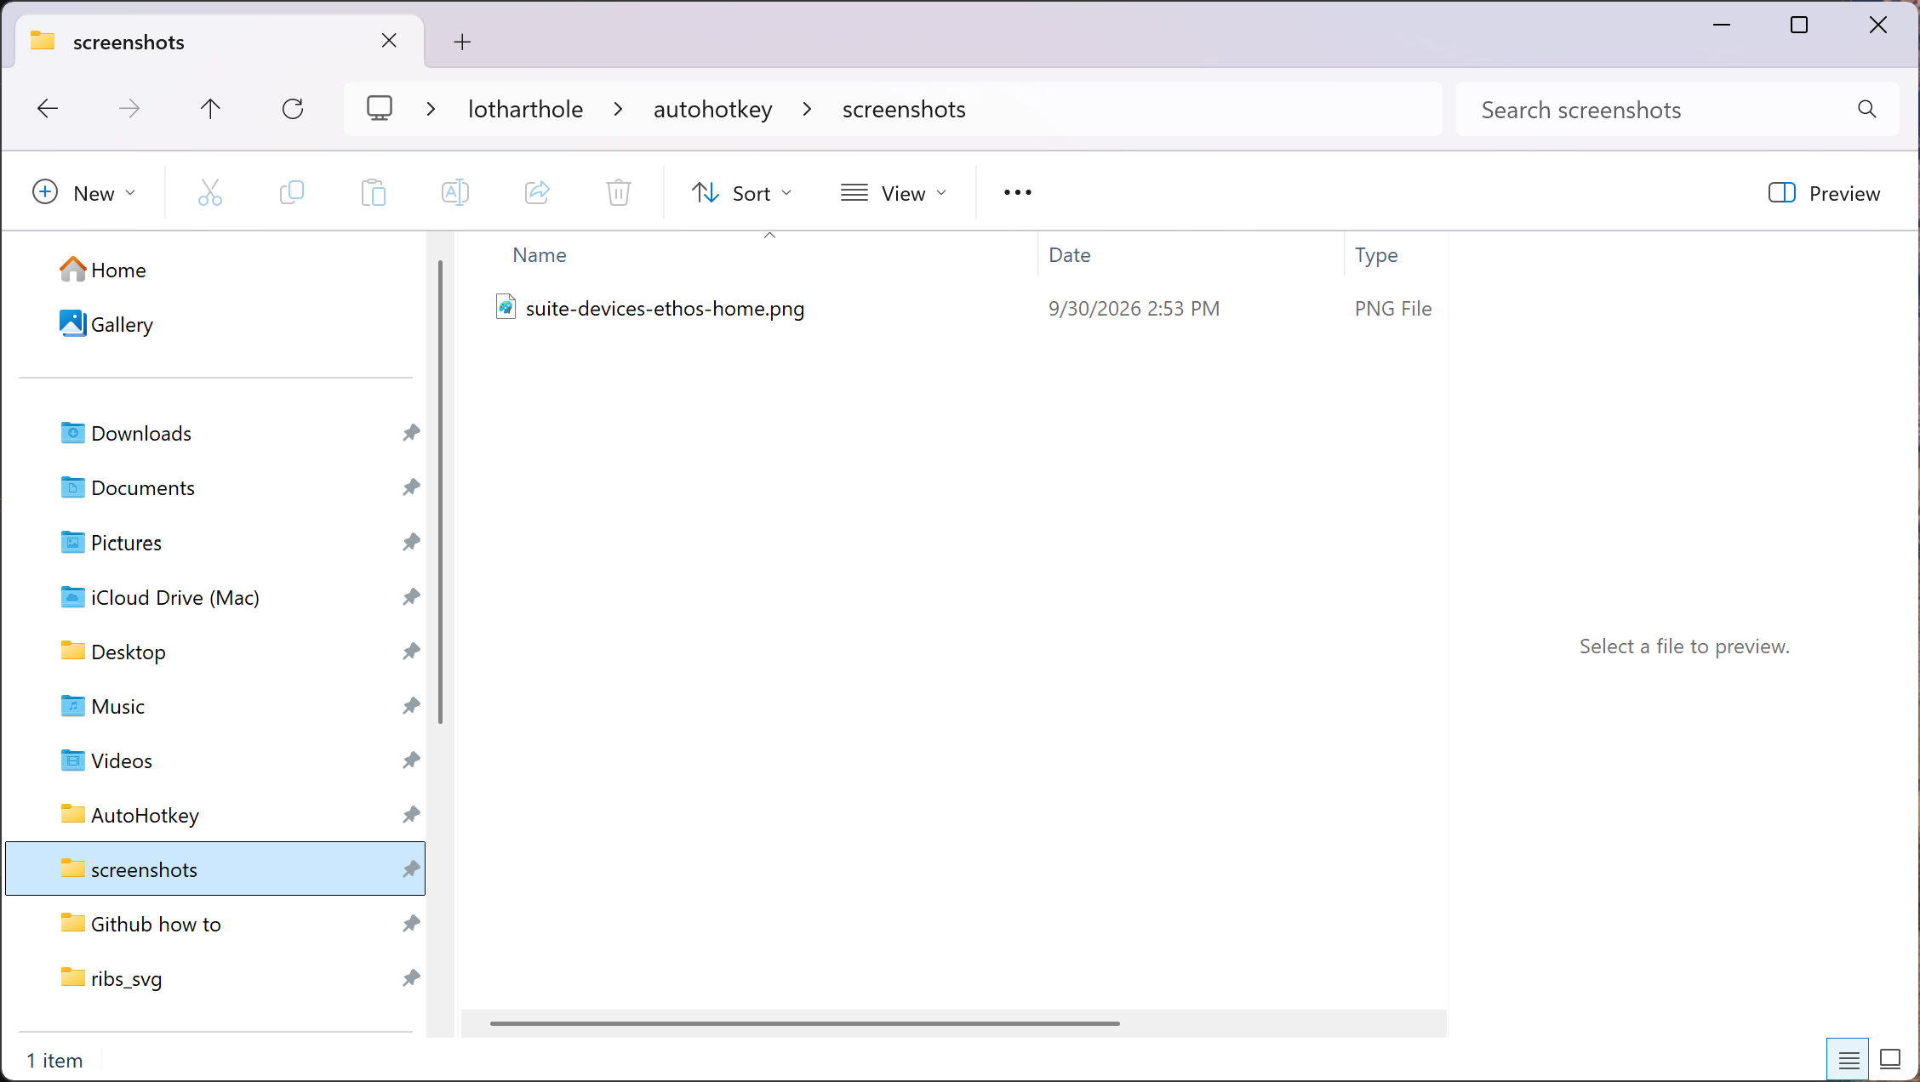

4. Check in the location ‘ScreenshotsPath’ that you defined in the config.ini file.

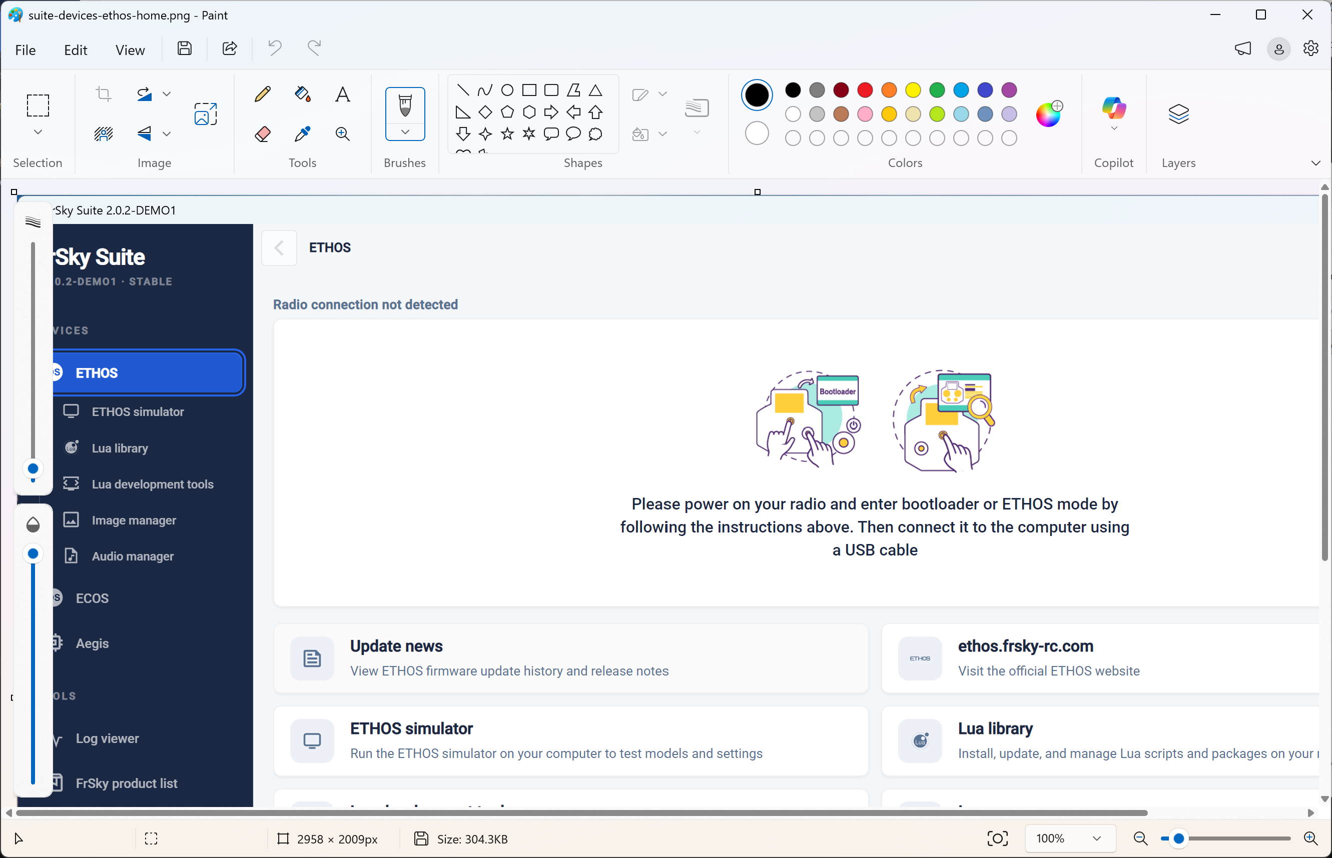

5. Double click on the screenshot. It will probably open in Paint. Check that the image size is 1800 x 1040 or close to it.

6. Please let me know the result.

7. Now you can do the next script. Double click on the most recent ‘FrSkySuite_Ethos_tools_revxx.ahk’ script. Follow the same process as above to generate these screenshots.

Notes
1. Please note that these scripts cannot check what is configured in Suite or whether the mock radio is turned on. They simply issues a sequence of keystrokes, so if Suite is set up incorrectly the wheels will fall off.
2. You should always close Suite before running the script again. If you don’t, it will close one running version. However, if you had two copies running it will not close both.

3. Please note you cannot do anything else on the PC while the script is running. There is no multi-tasking capability. If you switch to another program the AutoHotkey stream of key presses will be applied in the active window!

4. You can always abort the script with the escape key if necessary. The script stops running, but Suite stays open.

5. If you get an error for any reason you should abort the script with the Escape key, allowing you to take a manual screenshot to show me.

6. Please note that if you interrupt a script with Escape, it is very likely that you will have to check Suite and delete any Lua scripts. If you start Suite manually there should be NO Lua scripts installed.

7. If something goes wrong in a ‘tools’ script run, a copy of StabConfig may remain installed. This will disrupt normal script operation.
1. Open demo Suite manually
2. Go to the Lua Library.
3. Manually delete any installed Lua scripts, eg StabConfig.
4. Close demo Suite.
5. Run the ‘tools’ script again.

Things to check if the results are wrong

Image manager
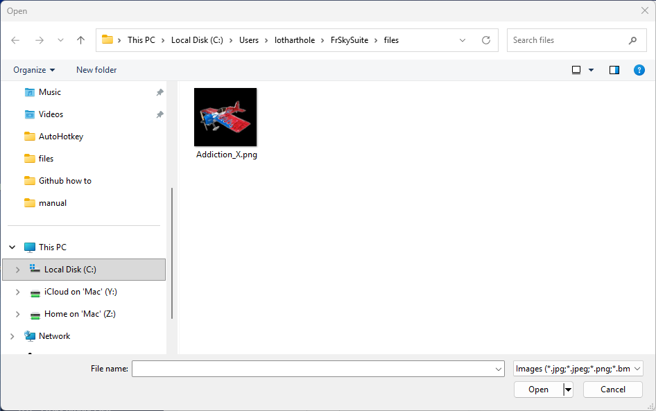

If you don’t get the correct screenshot in the Image manager section when running ‘FrSkySuite_Ethos_tools_revx.ahk’, you should check:

5. Open FrSky Suite, click on the ‘Image manager’ tab, click on ‘Add images or drop files’
and browse to FrSkySuite\files\Addiction_X.png and load the image. Then delete it again.
This establishes the path to the ‘files’ folder.

‘Tools’ script has gone off the rails
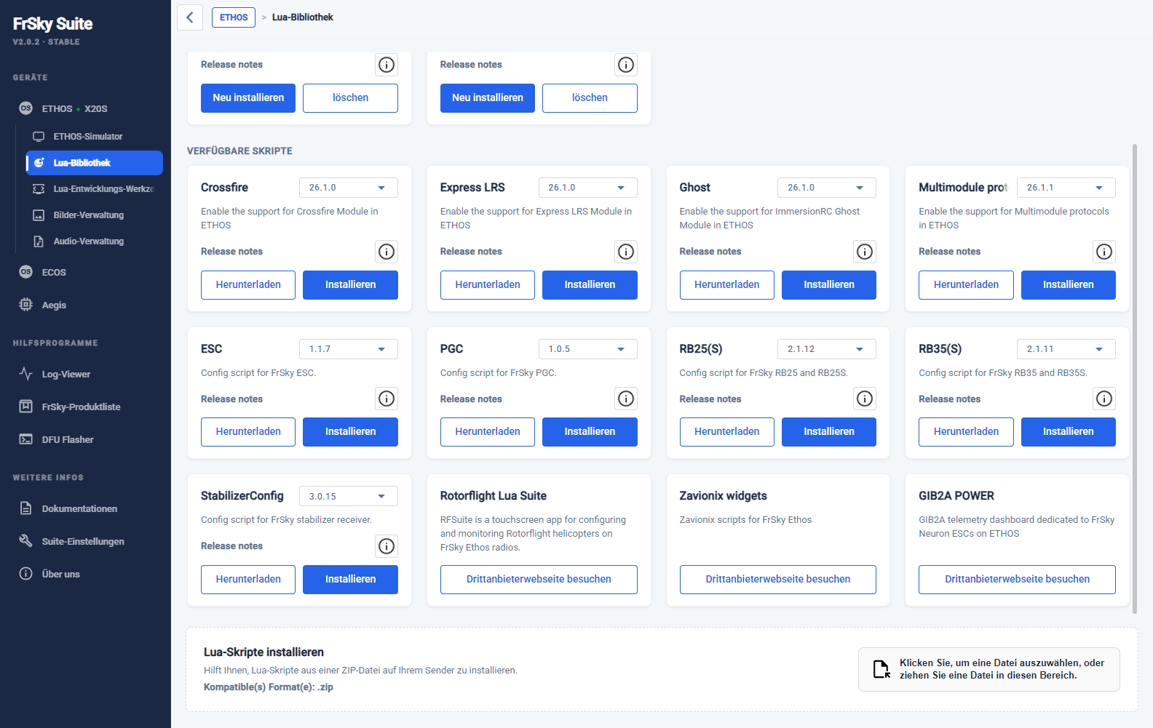

If there are many incorrect screenshots when running the ‘FrSkySuite_Ethos_tools_revx.ahk’ script, check the above screenshot. You should not have more than one StabConfig Lua installed.

1. Open demo Suite manually
2. Go to the Lua Library.
3. Manually delete any installed Lua scripts, eg StabConfig.
4. Close demo Suite.
5. Run the ‘tools’ script again.

